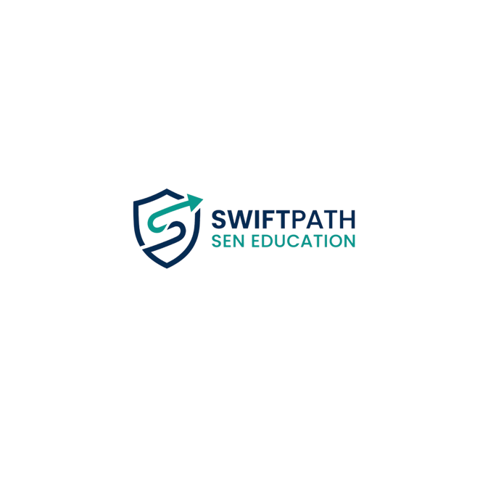

SwiftPath SEN Education

School Supplier Information Pack

About Us
SwiftPath SEN Education is a specialist education recruitment and staffing agency supplying high-quality Teaching Assistants, SEN Teaching Assistants, Learning Support Assistants, Behaviour Mentors, Cover Supervisors and other education professionals to schools across the United Kingdom.
Our mission is to provide reliable, compliant and safeguarding-focused staffing solutions that support schools in delivering exceptional educational outcomes for pupils, particularly those with Special Educational Needs and Disabilities (SEND).
We are committed to safer recruitment practices, safeguarding excellence and building long-term partnerships with schools, academies and multi-academy trusts.

Company Information
Company Name: SwiftPath SEN Education
Directors:
- Talal Yazbik
- Zahir Azam
Registered Address:
167–169 Great Portland Street
London
W1W 5PF
Email:
info@swiftpath.uk
Website:
www.swiftpath.uk

Services Provided
SwiftPath SEN Education supplies:
- SEN Teaching Assistants
- Teaching Assistants
- Learning Support Assistants
- Behaviour Mentors
- Cover Supervisors
- Intervention Staff
- Inclusion Support Staff
- Long-Term Supply Staff
- Permanent Recruitment Solutions

Safeguarding Commitment
SwiftPath SEN Education is fully committed to safeguarding and promoting the welfare of children and young people.
All candidates undergo rigorous compliance and safer recruitment checks before being introduced to any school.
We operate a zero-tolerance approach towards safeguarding concerns and require all candidates to adhere to safeguarding and child protection procedures at all times.
Designated Safeguarding Lead:
Talal Yazbik
Email:
info@swiftpath.uk

Recruitment & Vetting Process
Prior to placement, all candidates undergo:
✓ Application Form Review
✓ Face-to-Face or Virtual Interview
✓ Identity Verification
✓ Right to Work Verification
✓ Enhanced DBS Check
✓ DBS Update Service Verification (where applicable)
✓ Employment History Review
✓ Employment Gap Investigation
✓ Qualification Verification
✓ Two Professional References
✓ Safeguarding Screening
✓ Childcare Disqualification Declaration (where applicable)
✓ Conduct and Suitability Assessment

Insurance
SwiftPath SEN Education maintains appropriate business insurance cover including:
- Employers Liability Insurance
- Public Liability Insurance
- Professional Indemnity Insurance
Certificates are available upon request.

Compliance Policies
SwiftPath SEN Education maintains and reviews the following policies:
- Safeguarding & Child Protection Policy
- Safer Recruitment Policy
- Equality, Diversity & Inclusion Policy
- GDPR & Data Protection Policy
- Complaints Policy
- Health & Safety Policy
- Prevent Duty Policy
- Whistleblowing Policy
- Modern Slavery Policy
- Environmental & Sustainability Policy
- Candidate Code of Conduct
Copies are available upon request.

Data Protection
SwiftPath SEN Education complies with UK GDPR and the Data Protection Act 2018.
Personal data is processed lawfully, fairly and securely and is only retained for legitimate business purposes.

Why Schools Choose SwiftPath SEN Education
- Safeguarding-first approach
- Thorough candidate vetting
- SEN-focused recruitment expertise
- Responsive and reliable service
- Transparent communication
- Long-term partnership mindset
- Commitment to compliance and quality

Contact Us
SwiftPath SEN Education
Email:
info@swiftpath.uk
Registered Address:
167–169 Great Portland Street
London
W1W 5PF
We look forward to supporting your staffing requirements.

